PYTHAGORAS
Pearson Edexcel – Specimen 2 - Paper 1 (Non-Calculator) Foundation Tier

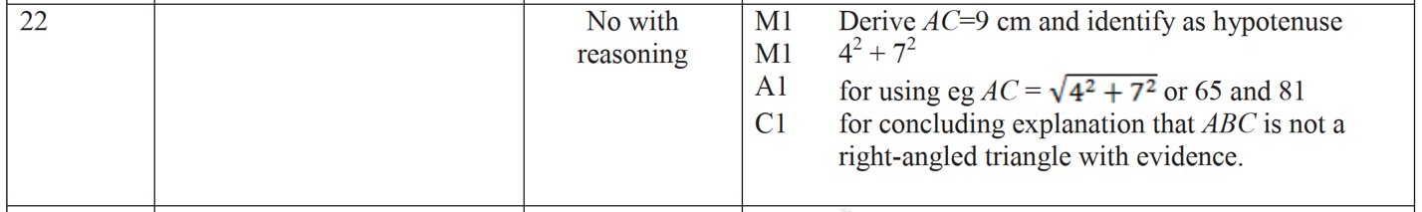

Pearson Edexcel – Specimen 2 - Paper 3 (Calculator) Foundation Tier

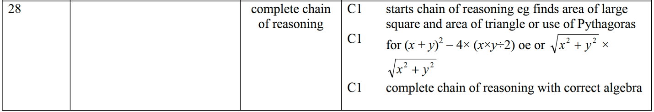

OCR Tuesday 11 June 2019 – Morning (Calculator) Foundation Tier

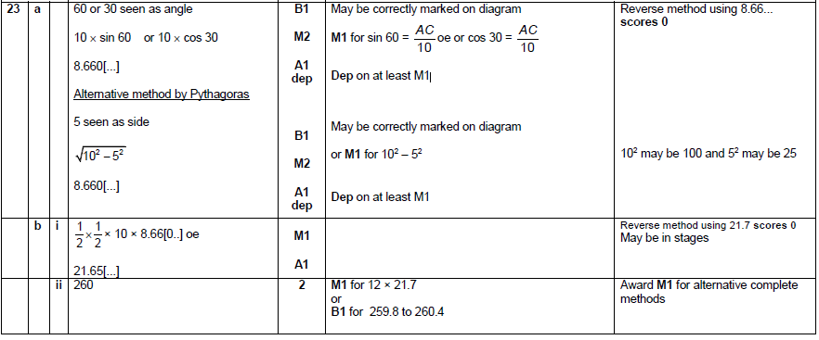

OCR Tuesday 6 November 2018 – Morning (Calculator) Foundation Tier

OCR Tuesday 12 June 2018– Morning (Calculator) Foundation Tier

OCR Thursday 2 November 2017– Morning (Calculator) Foundation Tier
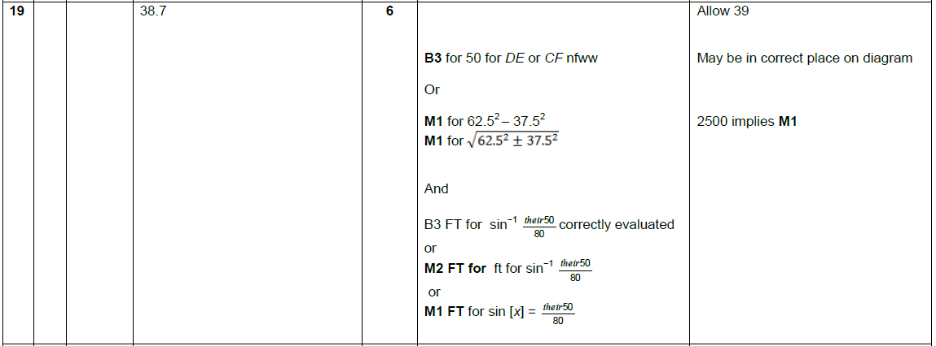

Pearson Edexcel –Sample Papers - Paper 2 (Calculator) Foundation Tier

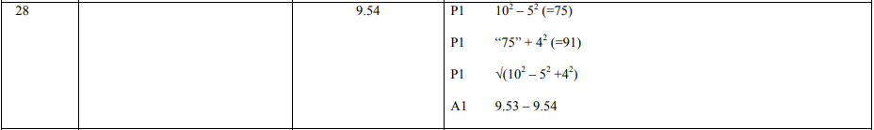

OCR Thursday 8 June 2017 – Morning (Non - Calculator) Foundation Tier

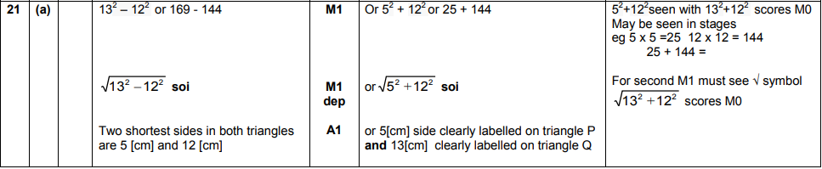
AQA Monday 8 June 2020 – Morning (Calculator) Foundation Tier

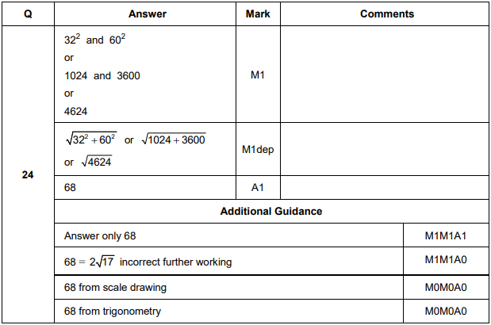

AQA Thursday 8 November 2018 – Morning (Calculator) Foundation Tier

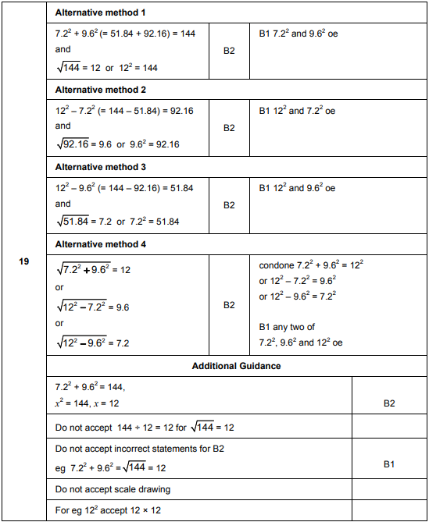

AQA Thursday 8 June 2017– Morning (Calculator) Foundation Tier

